***Diagram Design on***

***“Cash & Carry”***

***Prepared for:***

**Dr. Taslim Taher Assistant Professor**

**Mridha Md. Nafis Fuad Lecturer**

**Course Number & Name:**

**CSE 3224 - Information & System Design Lab**

***Prepared by:***

**Lab Section: A1**

**Group No: 1**

**BIDYARTHI PAUL ID: 20200104023**

**DIPTA BISWAS ID: 20200104013**

**MD. ABDULLAH WALID RIAZ ID: 20200104014**

**FARIHA TASNIM CHOWDHURY ID: 20200104001**

**ZAKIA SULTANA ID: 20200104005**

***Date: 18.07.2023***



***Ahsanullah University Of Science & Technology***

***Department of Computer Science and Engineering***

State diagrams:

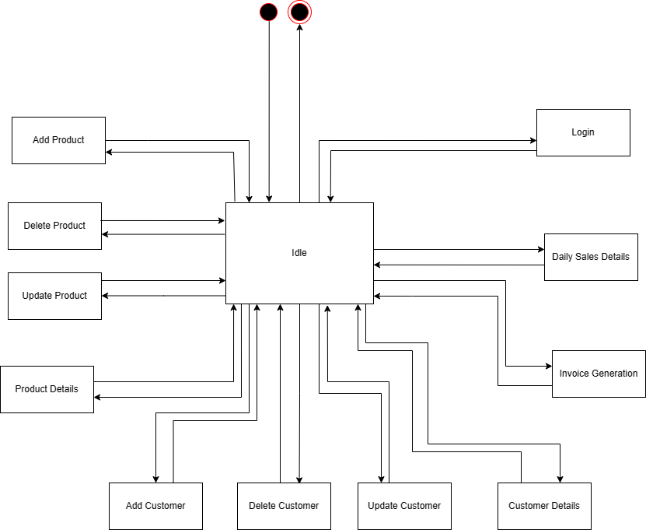

***Fig(1***)

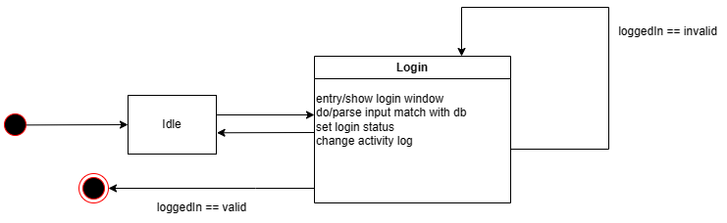

***Fig(2***)

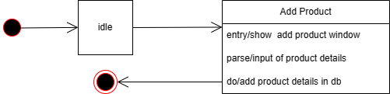

***Fig(3***)

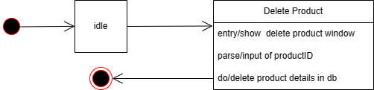

***Fig(4***)

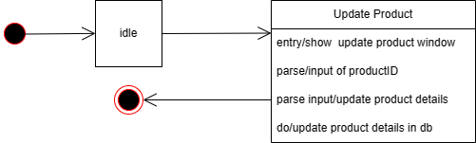

***Fig(5***)

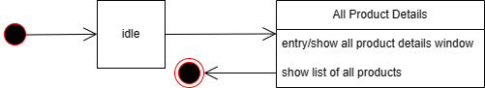

***Fig(6***)

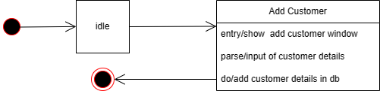

***Fig(7***)

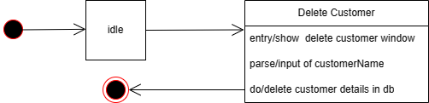

***Fig(8***)

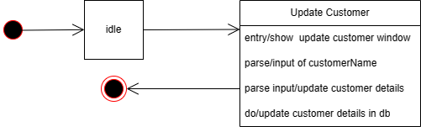

***Fig(9***)

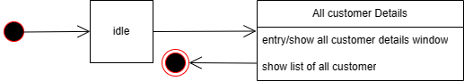

***Fig(10***)

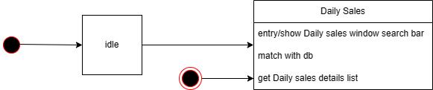

***Fig(11***)

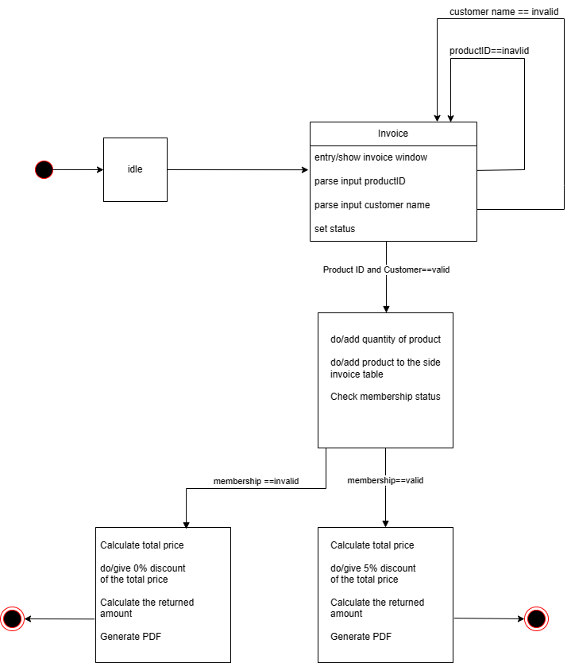

***Fig(12***)

Data flow diagram:

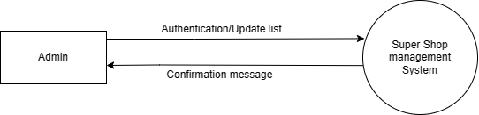

***Fig(1***)

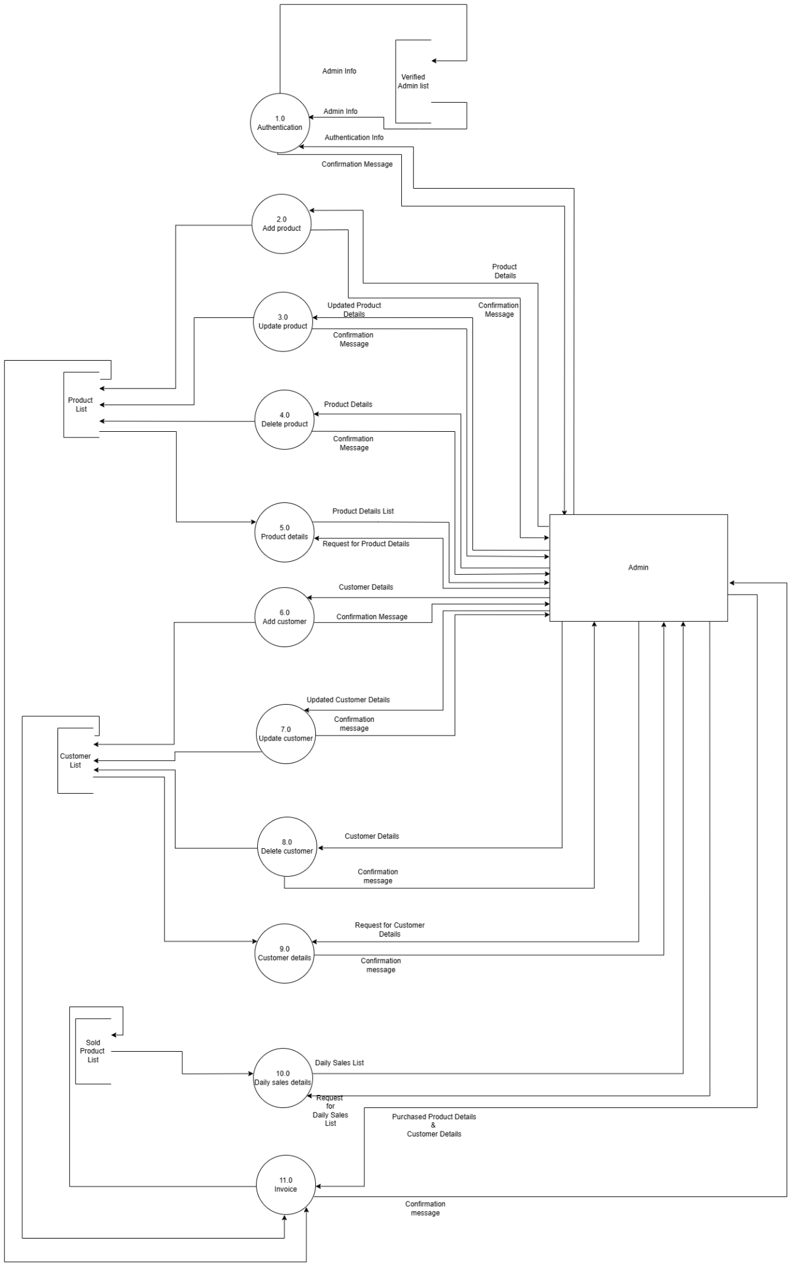

***Fig(2***)

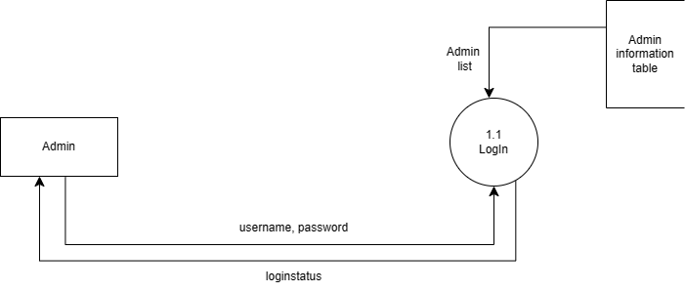

***Fig(3***)

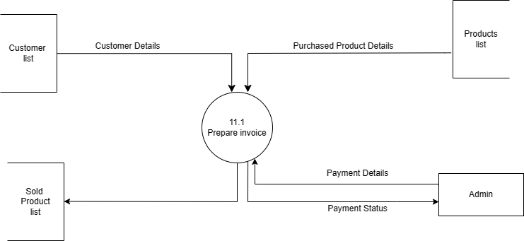

***Fig(4***)

Sequence diagram:

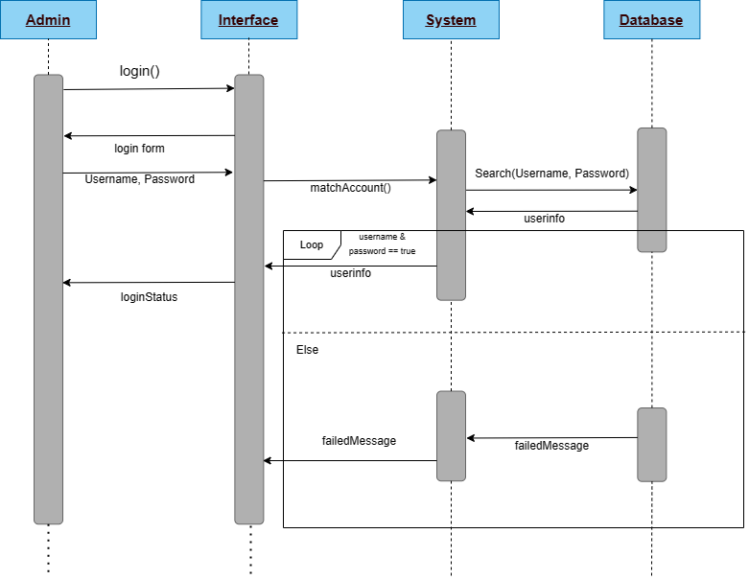

***Fig(1***)

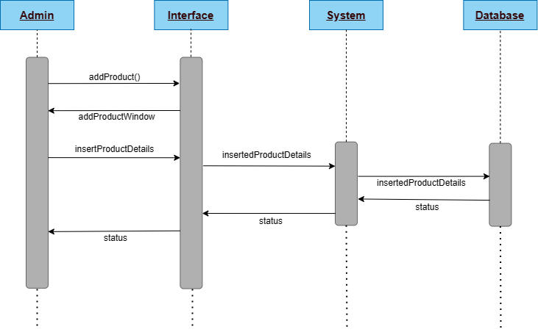

***Fig(2***)

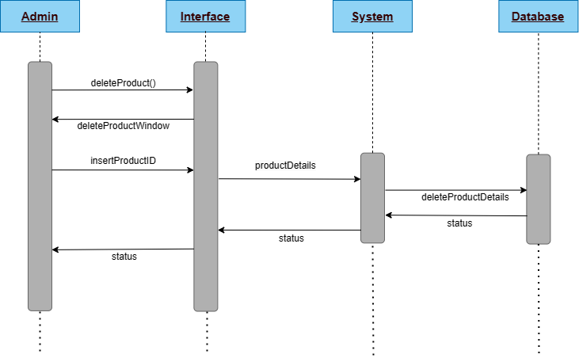

***Fig(3***)

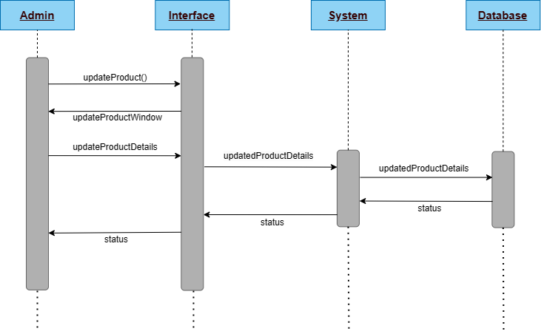

***Fig(4***)

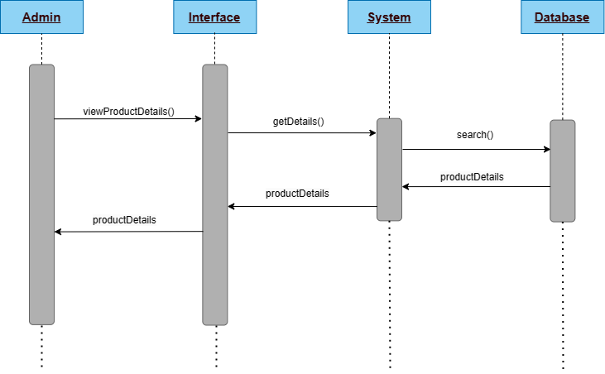

***Fig(5***)

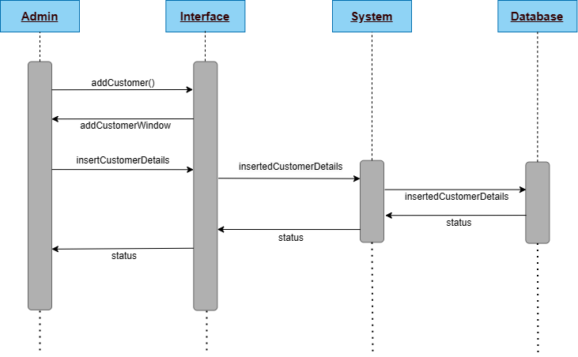

***Fig(6***)

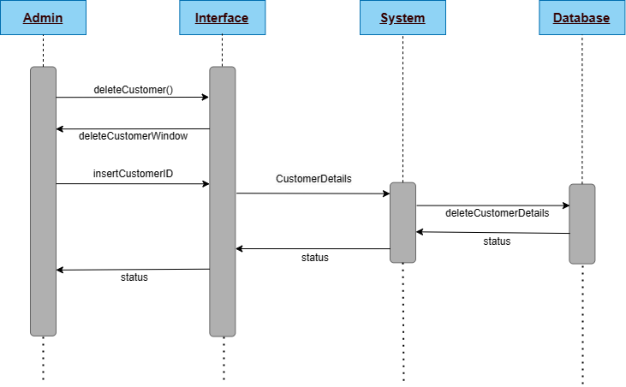

***Fig(7***)

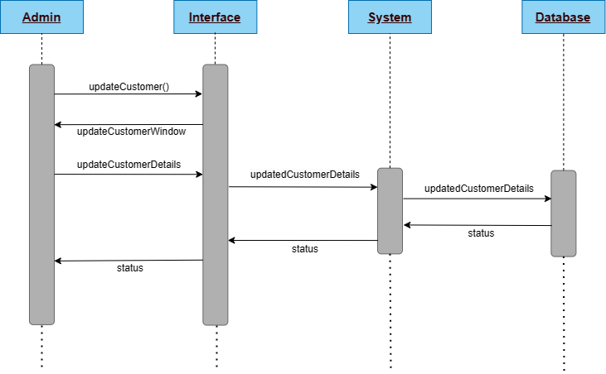

***Fig(8***)

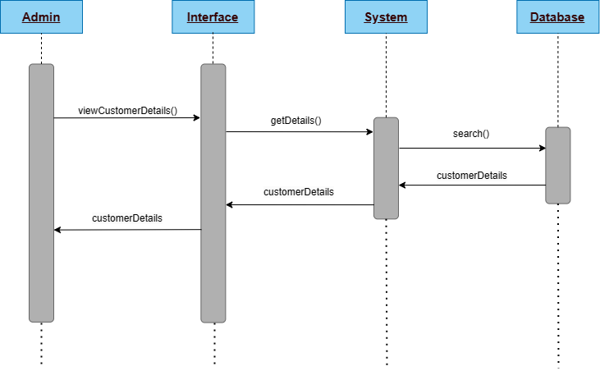

***Fig(9***)

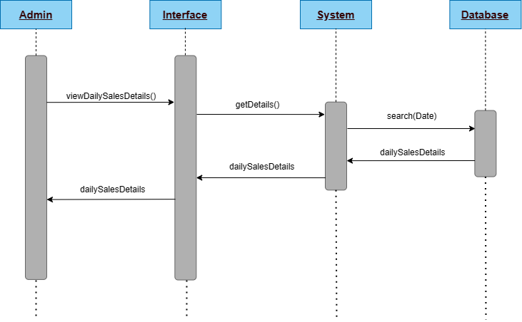

***Fig(10***)

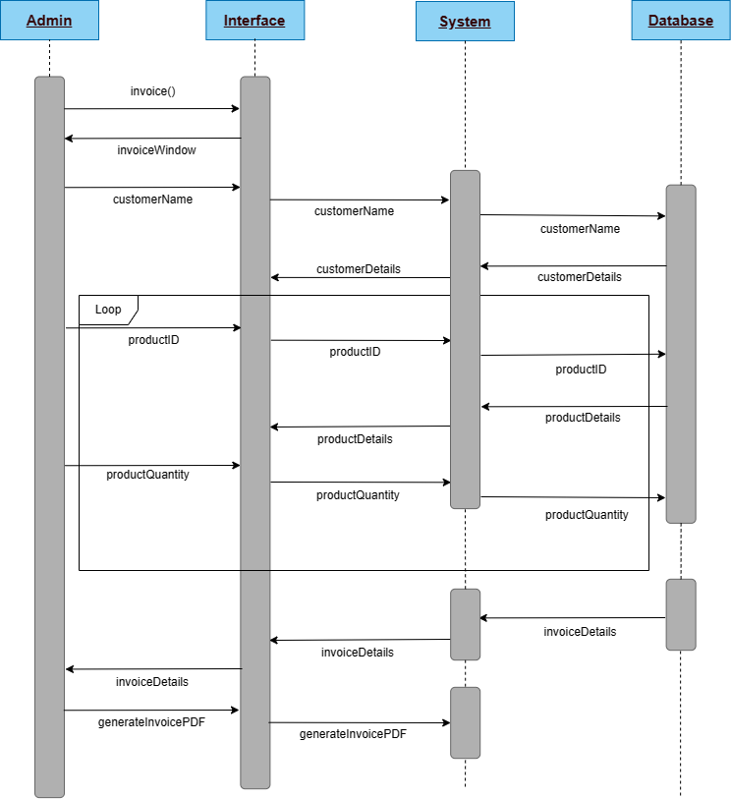

***Fig(11***)